43.4: a) As in Example 43.2,
Since 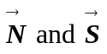are in opposite directions for a neutron, the antiparallel configuration is lower energy. This result is smaller than but comparable to that found in the example for protons.
b) 